**TrainersApp:**

**Trainers.js:**

export class Trainer {

  constructor(TrainerId, Name, Email, Phone, Technology, Skills) {

    this.TrainerId = TrainerId;

    this.Name = Name;

    this.Email = Email;

    this.Phone = Phone;

    this.Technology = Technology;

    this.Skills = Skills;

  }

}

**TrainersDetails.js:**

import React from 'react';

import { useParams } from 'react-router-dom';

import TrainersMock from './TrainersMock';

function TrainerDetail() {

  const { id } = useParams();

  const trainer = TrainersMock.find(t => t.TrainerId === id);

  if (!trainer) return <h2>Trainer not found</h2>;

  return (

    <div>

      <h1>Trainer Details</h1>

      <h2>{trainer.Name}</h2>

      <p>{trainer.Email}</p>

      <p>{trainer.Phone}</p>

      <ul>

        {trainer.Skills.map((skill, index) => (

          <li key={index}>{skill}</li>

        ))}

      </ul>

    </div>

  );

}

export default TrainerDetail;

**Trainerslist.js:**

import React from 'react';

import { Link } from 'react-router-dom';

function TrainersList({ trainers }) {

  return (

    <div>

      <h2>Trainers List</h2>

      <ul>

        {trainers.map((trainer) => (

          <li key={trainer.TrainerId}>

            <Link to={`/trainers/${trainer.TrainerId}`}>{trainer.Name}</Link>

          </li>

        ))}

      </ul>

    </div>

  );

}

export default TrainersList;

**TrainersMock.js:**

const TrainersMock = [

  {

    TrainerId: "t-syed8",

    Name: "Syed Khaleelullah",

    Email: "khaleelullah@cognizant.com",

    Phone: "97676516962",

    Technology: ".Net",

    Skills: ["C#","SQL Server","React",".NET Core"]

  },

  {

    TrainerId: "t-jojo",

    Name: "Jojo Jose",

    Email: "jojo@cognizant.com",

    Phone: "9897199231",

    Technology: "Java",

    Skills: ["Java", "Angular", "JSp","Spring"]

  },

  {

    TrainerId: "t-elisa",

    Name: "Elisa Jones",

    Email: "elisa@cognizant.com",

    Phone: "9871212235",

    Technology: "Python",

    Skills: ["Python", "Django", "Angular"]

  }

];

export default TrainersMock;

**Home.js:**

import React from 'react';

function Home() {

  return (

    <div>

      <h2>Welcome to My Academy trainers page</h2>

    </div>

  );

}

export default Home;

**App.js:**

import React from 'react';

import { BrowserRouter, Routes, Route, Link } from 'react-router-dom';

import Home from './Home';

import TrainersList from './Trainerlist';

import TrainerDetail from './TrainerDetails';

import TrainersMock from './TrainersMock';

function App() {

  return (

    <BrowserRouter>

      <div>

        <h1>My Academy Trainers App</h1>

        <nav>

          <Link to="/">Home</Link> | <Link to="/trainers">Show Trainers</Link>

        </nav>

        <hr />

        <Routes>

          <Route path="/" element={<Home />} />

          <Route path="/trainers" element={<TrainersList trainers={TrainersMock} />} />

          <Route path="/trainers/:id" element={<TrainerDetail />} />

        </Routes>

      </div>

    </BrowserRouter>

  );

}

export default App;

**OUTPUT:**

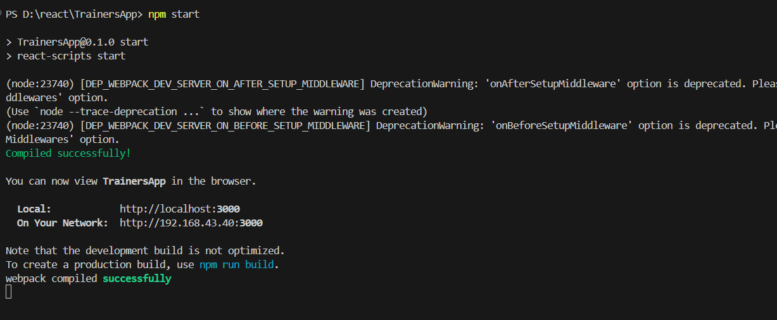

HOME:

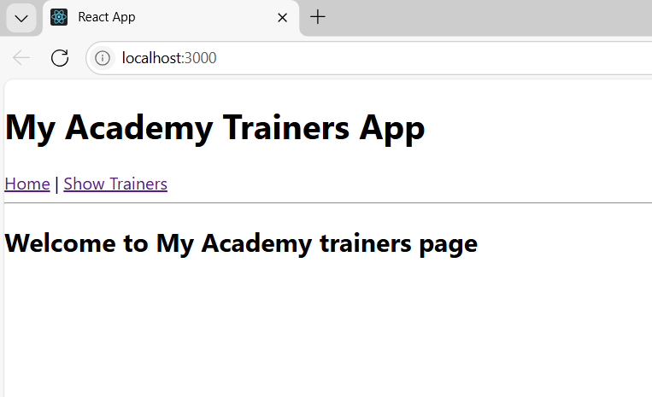

SHOW TRAINERS:

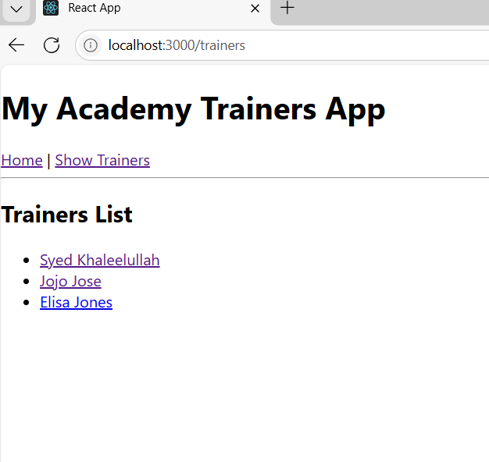

TRAINERS DETAILS:

